A STUDY ON CUSTOMER SATISFACTION TOWARDS HIMALAYA PRODUCTS

TABLE OF THE CONTENTS

CHAPTER | CHAPTER TITLE | PAGE  NUMBER
I | INTRODUCTION AND COMPANY PROFILE | 1
II | REVIEW OF LITERATURE | 5
III | RESEARCH METHODOLOGY | 32
IV | DATA ANALYSIS AND INTERPRETATION | 37
V | FINDINGS,SUGGESTION & CONCLUSION | 58
 | BIBLIOGRAPHY | 63
 | QUESTIONNAIRE | 65

CHAPTER-I
COMPANY PROFILE

Eighty years ago, on a visit to Burma, Himalaya’s founder, Mr. M. Manal, saw restless elephants being fed with a root to pacify them. The plant from which this was taken is Rauwolfia serpentina. Fascinated by the plant's effect on elephants, he had it scientifically evaluated. After extensive research, Serpina, the world’s first anti-hypertensive drug, was launched in 1934.
This legacy of researching nature forms the foundation of Himalaya’s operations. Himalaya uses the tools of modern science to create pharmaceutical-grade ayurvedic products. We have pioneered research that has converted Ayurveda’s herbal tradition into a complete range of proprietary formulations dedicated to healthy living and longevity. Today, these products have found acceptance with medical fraternities and serve the health and personal care needs of consumers in 67 countries.
ISO 9001: 2000 certification awarded for design, manufacture and marketing of herbal health care products.
Himalaya celebrates seventy-five years.

COMPANY PROFILE
The Himalaya Drug Company was founded in 1930 by Mr. M. Manal with a clear vision to bring Ayurveda to society in a contemporary form and to unravel the mystery behind the 5,000 year old system of medicine. This included referring to ancient ayurvedic texts,selecting indigenous herbs and subjecting the formulations to modern pharmacological,toxicological and safety tests to create new drugs and therapies
Eighty years ago, on a visit to Burma, Mr. Manal saw restless elephants being fed with a root to pacify them. The plant from which this was taken is Rauwolfia serpentina. Fascinated by the plant's effect on elephants, he had it scientifically evaluated. After extensive research,Serpinaâ, the world's first anti-hypertensive drug, was launched in 1934

The legacy of researching nature forms the foundation of Himalaya's operations. Himalaya has pioneered the use of modern science to rediscover and validate ayurveda's secrets.Cutting edge technology is employed to create pharmaceutical-grade ayurvedic products. As a confirmation that Himalaya is dedicated to providing the highest quality and consistency in herbal care, the Company was awarded an ISO 9001:2000 certification in 2003.
Since its inception, the company has focused on developing safe, natural and innovative remedies that will help people lead richer, healthier lives. Today, Himalaya products have been endorsed by 300,000 doctors around the globe and consumers in 67 countries rely on Himalaya for their health and personal care needs.
Ayurveda or the 'Science of Life' is an ancient, holistic system for diagnosis and treatment,perhaps the oldest system of medicine known to humanity. Fundamental to Ayurveda is the use of well-balanced combinations of plants and other agents in synergistic formulas.
At Himalaya, we have pioneered the use of modern science to rediscover and validate Ayurveda's secrets. We employ cutting edge research to create pharmaceutical-grade Ayurvedic products. Natural, effective and safe, these products have helped thousands of people live healthier, richer lives. Our focus is on wellness; on helping people get healthy and stay healthy.
At Himalaya, research begins with raw herbs chosen from traditional texts and from observations and experiences of indigenous plants. Our team of herbalists study texts, both traditional and scientific, exhaustively for relevant data. A few herbs of promising activity are short-listed. Polyherbal formulations of these short-listed herbs are made in order to provide a wider scope of pharmacological and cosmetic activity. Multicentered, double-blind trials according to WHO criteria further assist in scientifically validating the formulations. In the 1930's, Himalaya developed a pioneering experimental herb farm, which grew rare endangered herbs for commercial use. The company today has in addition to this an unparalleled database of dedicated herb suppliers, an herbarium, an agrotech division and a nursery
The standardization of herbal medicine is a more daunting challenge than the processes used for allopathic medicine. The tabletting of ayurvedic medicine is more arduous, with multiple granulating, processing and coating variables. Today, Himalaya's manufacturing unit has the largest coating capacity in Asia
Researching Ayurveda and capturing its benefits in formulations, has been the hallmark of Ayurveda at Himalaya. Using modern research methodology and manufacturing practice, Himalaya has made available to people all over the world, an alternate method of treatment,which has no known side effects

OVERVIEW
Himalaya's commitment to the community is part of our core values. Our mission is to make a positive difference to the communities in which we operate.We believe that every human being has a fundamental right to a good quality of life. This involves access to health, education, a clean environment and freedom from poverty.
Through our several community initiatives, which include programs aimed at ensuring better health, education, sustainable development and economic empowerment, we do our best to bring happiness to the lives of people who are marginalized and poor.

Our social philosophy is very simple - if we want to prosper as a business we need to ensure that the community prospers with us. By investing in the community we are investing in our business.
The company adopts third level of distribution channel. The manufacturer i.e. Himalaya Drug Company sends the its product to the C&F of the respective state, which works as a broker between the manufacturer and the whole seller. The whole seller meets the demand of retailer
i.e. chemist in the Pharma segment. Then in last the chemist fulfill the demand of the end consumer based on the prescription generated by the doctors and on the basis of customers own wish.

CHAPTER-II
REVIEW OF LITERATURE

- Witt & Bruce, (2018). The information about the brand have been used by the other group members also affect the decision to skip the existing brand and to move on to the purchase those brand that is using by other group members (Witt, 1969). So the great orientation to customer’s members impact to other members to buy particular brand used by the other group members (Moschis, 1976). Many factors intended to purchase intention which is customer knowledge, perception of customers, product packaging or design and celebrity endorsement etc
- Duverger, P, & Wang, X(2018): Customer satisfaction traditionally focuses on large data sets collected over long periods of time across several business units. Business Unit managers or property managers a have a different focus in that they need to address dissatisfaction issues on monthly basis on property basis. In search of zero defects they are confined to small sample lacking power where they cannot draw the relative importance of each variable responsible for making the overall perceived quality in the customer’s base. We propose to use Bayesian approach to estimate the relative importance of predictors in the presence of small samples. Based on 12 consecutive months of customer satisfaction survey data collected in hotel, we show how the hotel manager can easily prioritize his or quality management action plan on 5 a monthly basis. The result of our study complement the current customer satisfaction research methods while managing limited resources
- Lymn, M., & Brewster, Z .W. (2019): Many U.S restaurants have recently adopted on tipping policies or are considering doing so these study examines the effect of such moves’ away from tipping on restaurants online customer ratings. The results indicate that Rather, R, & Sharma, J. (2019): Hotel Operator struggle to satisfy the wants of their customers and subsequently retain them by attempting to know the factors could build up a strong brand relationship and loyal customer base. Over the recent decade,Practitioners have engaged in making and maintaining the future connections with the customers and regard brand loyalty as their main goal in developing business and increasing the competition within the market. This study was done in order to analyze and understand the four marketing perspectives such as customer brand Identification,Brand satisfaction, Brand Commitment, Brand loyalty. For these survey 180 respondents of hospitality Brands. This paer incorporates the factors that regulate to brand loyalty in marketing literature and provide strategies to hospitality manager for ncreasing Brand loyal Customers.
- Lee, S., Sun, K,.A.,Wu, L., & Xiao, Q. (2019): The purpose of the current study is to investigate the existence of a moderating effect of a green initiative on the relationship between the service quality and customers satisfaction in the Chinese hotel Context. The study a 2 *2 between subjects experimental design using Scenarios. Four Scenarios provide a mixed combination or low case for a hotel green Participation, and good or poor cases for service quality. The study uses the survey method to collect data from the Chinese Guest. It finds the main effects of service quality on customers satisfaction and significant moderating role for green initiatives on the relationship between service quality and customer satisfaction, but increasingly found and opposite direction of the moderating role to be hypothesized. The study results also reveal on insignificant main effect of green initiative on customers satisfaction.
- U. Dineshkumar, P. Vikramman(2020): In the customers future purchase intentions customers’ satisfaction plays an important role and is an important factor. In main aim of this paper is to identify the attitude and behavior of the customers who are purchasing in the organized retail outlets in the Erode City of Tamil Nadu state in India. Satisfied Customers are likely to tell other of their favorable responses and 6 those who are not satisfied are likely to give negative responses. For the survey 200 questionnaire have been randomly distributed to retail customers. For these study chi-squre test, correlation has been performed and the data is analyzed
- Zeithaml et al. 2020 :Customer satisfaction is significantly influenced by the customer’s evaluation of product or service features. Thus, firms also study concerning satisfaction what features and attributes of their services customer measure most and that firms measures the perceptions of those features and overall service satisfaction. In this regard, research has found that normally customers make trade-offs among service like, price level versus service quality or friendliness of personnel versus customization.
- According to Hoyer, Macinnis ( 2020),“Consumer behaviour reflects the totality of consumers’ decisions with respect to the acquisition, consumption, and disposition of goods, services, activities, experiences, people, and ideas by (human) decision-making units (over time).”
- According to Kotler and Armstrong (2020), “Consumer buyer behaviour refers to the buying behaviour of final consumers- individuals and households who buy goods and services for personal consumption. All of these final consumers combine to make up the consumer market.”
- According to Solomon (2020), “Consumer behaviour is the process involved when individuals or groups select, purchase, use, or dispose of products, services, ideas or experiences to satisfy needs and wants.”
- Peter F.Drucker (2020) was apt in saying, “it is the consumer who determines what business is…. What the consumer thinks he is buying, what he considers ‘value’ is decisive – it determines what a business is, what it produces and whether it will prosper”. The importance of consumption was recognized even in early periods when Adam Smith (1776) stated that “consumption is the sole end-purpose of all production”
- William L. Willkie (2020)defined consumer behaviour as‘‘the activities that are selecting, purchasing and using products and services in order to satisfy the needs and desires in which people engage’’. Such activities comprises of mental and emotional process, in addition to physical actions.
- According to Belch and Belch (2021), “Consumer behaviour is the process and activities people engage in when searching for, selecting, purchasing, using,7 evaluating, and disposing of products and service so as to satisfy their needs and desires
- Schiffman and Kanuk (2021) stated consumer behaviour is ‘‘the behaviour which consumers show forth in searching for, purchasing, using and evaluating products,services and ideas which they expect will satisfy their needs’’. Here, the term‘evaluation’ has been used by Schiffman and Kanuk in the context of re-purchase. In case of first purchase consumer’s mind will first evaluate and finally adopt or reject the product. Thus, consumer behaviour entangles all the acts of individuals which entangle buying and using products, comprising of the decision process which precede and determine these acts. However, the factors precede and determine consumer behaviour and they are a combination of external and internal influences that a consumer interacts constantly
- Engel, Kollat and Blackwell (2021) define consumer behaviour as “acts of individuals directly involved in obtaining and using economic goods and services, including the decision processes that precede and determine these acts”. They add further that though the word behaviour is used to include only the overt or observable actions, it is increasingly being recognized that the overt purchasing act is only one (the discernible) portion of the decision process. Consumer behaviour, viewed more rationally, would include the less discernible, but nevertheless important process that underlie and accompany consumption. In effect it involves the study not only of what people consume but when, how often, and under what condition goods and services are consumed.
- According to Levin (2021), this is the competition of product augmentation, not competition between what companies produced in their factories, but between what they add to their factory output in the form of brand attributes of the product,advertisement, readily availability of services, financing, delivery arrangement and other things that people value
- Kesavan (2021) investigated the consumption pattern of milk and milk products for Kerala state by using cross – section data collected in year 1973 – 74 on 1150 households. Projections of consumption of liquid milk and expenditure on milk products revealed that at different rates of growth in per capita income, the demand of milk and milk products would increase considerable by the end of the decade. Also, it was found that per capita total expenditure has positive relation with consumption of 8 milk products. Education and household size were found to exert no significant influence on milk and milk products consumption in general
- Subramanyam et al.(2021) studied the consumer opinion on purchase of dairy products in Visakhapatnam and they found that a large number of consumers were preferring to purchase the consumer products including groceries and dairy products from the private retail shops which are followed by super bazar and consumer co-operatives.
- Joshi (2021) investigated on the food purchasing habits and consumer awareness in Dharwad among rural and urban housewives. The results indicated that majority of the urban respondents purchased the groceries like cereals, pulses, oils, spices and sugar on monthly basis. While perishables like fruits, eggs and meat were purchased once in week and milk was purchased daily. Rural respondents purchased cereals,pulses, oils, spices, sugar and fruits once in week and milk daily. Regarding place of purchase, 83per cent of urban and 99per cent of rural respondents purchased all the groceries like sugar, rice, and wheat from fair price shops. Both rural and urban respondents purchased groceries (99% each), perishables (89% and 99% respectively); ready to use foods (97% and 87% respectively) and commercially available foods (96% and 6% respectively) from retail shops. Price, quality and weight of the products were the important factors considered by both rural and urban respondents while purchasing of food items.
- Hugar et al. (2021) carried out a study on dynamics of consumer behaviour in vegetable marketing in Dharwad city. Low income groups purchased lesser quantity (3.25kg/week) of vegetables as compared to medium (5.40 kg/week) and high income groups (4.66 kg/week). Majority of low income group preferred to purchase vegetables from producers because of reasonable price. High and medium income families preferred stall vendors for the purchase of vegetables because of better quality and correct weight age.

Customer Satisfaction in Herbal Personal Care Products

Customer satisfaction in the herbal personal care industry has gained significant attention due to the growing demand for natural and chemical-free products. Himalaya, a well-established brand in this sector, has successfully positioned itself by emphasizing Ayurvedic formulations and herbal ingredients. According to Singh & Sharma (2021), customer satisfaction in the herbal cosmetic market is primarily driven by factors such as product effectiveness, affordability, brand trust, and availability. Himalaya’s wide range of skincare, haircare, and wellness products ensures accessibility for diverse customer segments.

A study by Mehta & Patel (2020) highlights that the preference for herbal products is increasing as consumers become more aware of the potential side effects of synthetic chemicals found in conventional beauty and health products. Himalaya has leveraged this trend by offering herbal alternatives with clinically tested ingredients. However, customer satisfaction is also influenced by packaging, fragrance, and ease of application. Consumers expect not just herbal authenticity but also a premium experience similar to chemical-based alternatives.

Furthermore, research suggests that loyalty towards herbal brands like Himalaya is driven by personal experiences and word-of-mouth recommendations. Customers satisfied with product performance often become brand advocates, contributing to organic growth. To maintain customer satisfaction, Himalaya must continuously innovate and ensure consistent quality while addressing consumer feedback.

Role of Brand Trust in Customer Satisfaction with Himalaya Products

Brand trust plays a crucial role in customer satisfaction, particularly in the herbal products industry, where customers rely on the authenticity and efficacy of natural ingredients. A study by Raj & Bhatia (2019) found that trust in herbal brands like Himalaya is built through years of positive consumer experiences, ethical business practices, and product transparency. Customers feel reassured by the brand’s commitment to Ayurvedic science and clinically tested formulations.

Himalaya’s long-standing reputation as a leader in herbal healthcare has strengthened its customer base. Research by Nair et al. (2021) suggests that brand credibility significantly impacts customer satisfaction, as consumers are more likely to trust well-established brands over lesser-known ones. The company’s strategic marketing, which includes educational campaigns on the benefits of herbal ingredients, has enhanced consumer confidence.

However, trust alone is not sufficient to maintain high satisfaction levels. A study by Verma & Joshi (2020) emphasized that consistent product quality, affordability, and easy accessibility are equally important in retaining customers. If a brand fails to meet customer expectations regarding product performance or availability, satisfaction declines despite a strong reputation.

In conclusion, Himalaya’s customer satisfaction is largely driven by brand trust, reinforced by high-quality products and continuous consumer engagement. Maintaining transparency and responding to customer concerns proactively will help sustain long-term satisfaction.

Impact of Product Quality and Effectiveness on Himalaya’s Customer Satisfaction

The quality and effectiveness of a product are fundamental to customer satisfaction, particularly in the health and personal care industry. Himalaya’s extensive research-based approach in formulating its products has been a key factor in its success. According to Gupta & Kumar (2022), product effectiveness plays the most significant role in customer retention, as consumers expect visible and tangible benefits from herbal formulations.

Himalaya’s unique selling proposition (USP) lies in its scientifically validated Ayurvedic products. A study by Sharma & Reddy (2020) found that consumers who experienced positive outcomes with Himalaya’s skincare, haircare, and healthcare products demonstrated a higher level of satisfaction and brand loyalty. The study further highlighted that customers were particularly satisfied with the brand’s acne treatment products, baby care range, and herbal supplements due to their proven efficacy.

Despite the strong reputation, occasional product inconsistencies can affect customer satisfaction. Jain et al. (2021) pointed out that variations in herbal product formulations, fragrance changes, or effectiveness across different batches could lead to customer dissatisfaction. Consumers expect uniformity in product performance, and deviations may result in negative reviews or decreased trust.

To ensure sustained satisfaction, Himalaya must focus on stringent quality control, continuous innovation, and customer-centric improvements based on consumer feedback.

Influence of Pricing and Accessibility on Customer Satisfaction with Himalaya Products

Pricing and accessibility are major factors influencing customer satisfaction in the herbal product industry. Himalaya has positioned itself as an affordable yet high-quality herbal brand, catering to middle-income and budget-conscious consumers. Research by Mehta & Chopra (2021) suggests that customers perceive Himalaya products as cost-effective alternatives to expensive herbal and organic brands, contributing to high satisfaction levels.

A study by Sinha & Patel (2020) indicated that while customers appreciate the affordability of Himalaya’s products, accessibility is an equally critical factor. Himalaya products are widely available in pharmacies, supermarkets, and online platforms, ensuring convenience for customers. The ease of purchasing these products enhances customer loyalty and satisfaction.

However, the study also revealed that certain premium herbal brands provide higher-end products with advanced formulations, which could attract customers willing to pay more for exclusivity. Although Himalaya offers quality products at competitive prices, it must continuously upgrade its formulations and expand its premium range to cater to evolving consumer demands.

Additionally, promotional discounts and loyalty programs can further enhance customer satisfaction. By maintaining a balance between affordability, quality, and accessibility, Himalaya can continue to strengthen its consumer base and overall market presence.

Role of Consumer Perception and Marketing Strategies in Himalaya’s Customer Satisfaction

Consumer perception and marketing strategies significantly influence customer satisfaction with herbal products. Himalaya has successfully created a strong brand identity by positioning itself as a natural and effective solution for personal care and wellness. A study by Rao & Mishra (2021) suggests that Himalaya’s marketing campaigns emphasizing Ayurvedic heritage and scientific validation have contributed to a positive consumer perception.

Social media and digital marketing play a crucial role in shaping consumer attitudes towards the brand. According to Kapoor & Sharma (2020), influencer endorsements and customer testimonials have strengthened Himalaya’s credibility and trustworthiness. Many consumers rely on online reviews before purchasing herbal products, and positive feedback enhances satisfaction and loyalty.

However, consumer perception is also influenced by packaging, fragrance, and overall user experience. A study by Verma et al. (2022) found that while Himalaya’s herbal formulations were highly appreciated, some consumers desired more attractive packaging and modernized branding to compete with premium herbal brands.

To sustain customer satisfaction, Himalaya must continuously innovate its marketing strategies, enhance digital engagement, and ensure that its branding aligns with evolving consumer preferences. By maintaining authenticity while embracing contemporary trends, the brand can continue to thrive in the competitive herbal market.

The Influence of Herbal Ingredients on Customer Satisfaction with Himalaya Products

The use of herbal ingredients is a key factor in customer satisfaction with Himalaya products. With increasing awareness of the benefits of natural remedies, consumers seek products that are free from harmful chemicals and synthetic additives. A study by Kumar & Verghese (2022) highlighted that customers trust Himalaya due to its commitment to Ayurvedic formulations, which incorporate traditional herbs like neem, turmeric, and aloe vera. These ingredients are widely recognized for their skin-healing and medicinal properties, making Himalaya a preferred choice among health-conscious consumers.

However, research by Singh & Patel (2021) suggests that while herbal ingredients attract consumers, product efficacy and visible results ultimately determine satisfaction levels. Customers expect these natural ingredients to perform as effectively as synthetic alternatives, and any delay in results can lead to dissatisfaction. The study also noted that consumer preference for herbal products has grown due to concerns over allergies and side effects associated with chemical-based products.

To enhance customer satisfaction, Himalaya must continue educating consumers about the long-term benefits of herbal formulations. Transparent communication regarding the scientific validation of ingredients and clinical results can further strengthen customer confidence and brand loyalty.

The Role of Customer Service and After-Sales Support in Himalaya’s Consumer Satisfaction

Beyond product quality, customer service and after-sales support play a crucial role in determining customer satisfaction with Himalaya products. A study by Nanda & Kapoor (2023) found that effective customer service, including prompt responses to queries and efficient handling of complaints, enhances consumer trust in a brand. Himalaya’s strong retail and online presence has facilitated accessibility, but challenges such as product returns, grievances related to effectiveness, and counterfeit products require effective resolution strategies.

According to Mehta & Sharma (2022), brands that actively engage with customers through helplines, chat support, and interactive social media platforms enjoy higher satisfaction rates. The study emphasized that Himalaya’s reputation as a consumer-friendly brand is further reinforced when customers receive clear and satisfactory responses to their concerns. Additionally, customer loyalty programs, discounts, and personalized recommendations increase retention rates.

However, the study also suggested that while Himalaya performs well in product distribution, it must continuously improve its online consumer interaction, particularly for e-commerce shoppers who rely on virtual assistance. By refining its customer support system and proactively addressing consumer concerns, Himalaya can further elevate its customer satisfaction levels.

The Psychological Impact of Herbal Branding on Consumer Satisfaction

Branding strategies play a significant psychological role in shaping consumer perception and satisfaction. Himalaya’s branding, which emphasizes purity, tradition, and scientific research, has created a strong emotional connection with consumers. A study by Rao & Deshmukh (2021) found that customers associate Himalaya products with safety, reliability, and holistic well-being. This perception influences their satisfaction, as consumers feel they are making healthier choices.

Another study by Joshi & Tandon (2022) suggested that the effectiveness of herbal branding lies in its ability to tap into cultural and psychological preferences. Since Ayurveda has deep roots in Indian tradition, Himalaya’s positioning as a science-backed herbal brand fosters a sense of trust. Customers who prioritize wellness over cosmetic benefits tend to have higher satisfaction with Himalaya products, as they align with their lifestyle choices.

However, the study also noted that newer generations may be drawn toward more contemporary branding styles. To maintain consumer satisfaction across different demographics, Himalaya must evolve its branding while preserving its core identity. A balance between traditional Ayurvedic appeal and modern branding elements can help sustain and expand its satisfied customer base.

The Impact of Product Innovation on Customer Satisfaction with Himalaya Products

Continuous product innovation is essential in maintaining high customer satisfaction in the herbal personal care industry. Himalaya has expanded its product line from traditional skincare and healthcare solutions to specialized products such as anti-hair fall creams, vitamin-enriched facial wipes, and probiotic supplements. A study by Sharma & Gupta (2023) found that introducing new and improved formulas based on consumer needs significantly increases brand satisfaction and loyalty.

Another study by Patel & Reddy (2021) emphasized that innovation in herbal formulations, such as the infusion of modern skincare technology with Ayurvedic herbs, enhances customer interest. Customers appreciate brands that offer cutting-edge solutions while staying true to their core philosophy. Himalaya’s research and development (R&D) efforts in improving product texture, absorption, and efficacy have contributed to higher satisfaction levels.

However, the study also highlighted that excessive product variation without clear differentiation can confuse consumers. Himalaya must ensure that its innovations align with market demand and clearly communicate the benefits of each new product. By staying ahead of consumer expectations and consistently introducing effective herbal solutions, the brand can maintain its competitive edge and customer satisfaction.

The Role of Ethical Sourcing and Sustainability in Himalaya’s Consumer Satisfaction

Modern consumers are increasingly prioritizing sustainability and ethical sourcing in their purchasing decisions. A study by Verma & Chatterjee (2023) revealed that customers who perceive a brand as environmentally responsible tend to exhibit higher satisfaction and brand loyalty. Himalaya’s commitment to sustainable herbal sourcing, cruelty-free testing, and eco-friendly packaging has positively influenced consumer trust.

According to research by Nair & Bose (2022), ethical practices in ingredient sourcing contribute to customer satisfaction by reinforcing the brand’s authenticity. Himalaya has actively promoted its use of responsibly sourced herbs and eco-conscious production methods, which appeal to environmentally conscious consumers. The study found that customers who value sustainability are more likely to choose Himalaya over competitors that lack similar commitments.

Despite this, the study also identified areas for improvement. Some consumers feel that Himalaya could enhance its sustainable initiatives by incorporating more biodegradable packaging and increasing transparency regarding its supply chain. By strengthening its sustainability efforts and clearly communicating its ethical initiatives, Himalaya can further enhance customer satisfaction while solidifying its reputation as a responsible herbal brand.

The Influence of Brand Trust on Customer Satisfaction Towards Himalaya Products

Brand trust plays a significant role in shaping customer satisfaction in the herbal personal care industry. Himalaya has established itself as a trusted brand by consistently delivering quality herbal-based products backed by scientific research. A study by Raj & Mehta (2023) emphasized that long-standing consumer trust in Himalaya stems from its commitment to Ayurvedic formulations and its clinically tested products. Consumers who trust the brand are more likely to repurchase and recommend Himalaya products to others, contributing to overall satisfaction.

A related study by Verghese & Kumar (2022) found that trust is built not only on product effectiveness but also on factors such as transparent labeling, quality assurance, and ethical business practices. Consumers appreciate Himalaya’s clear ingredient disclosure and its avoidance of harmful chemicals. The research further highlighted that consumers who have positive past experiences with Himalaya products are more forgiving of minor product variations or delays in results.

However, the study also pointed out that maintaining trust requires continuous efforts in innovation, customer engagement, and addressing consumer grievances promptly. As consumer expectations evolve, Himalaya must reinforce its reliability through consistent quality and strong consumer relationships to sustain high satisfaction levels.

The Role of Digital Marketing in Enhancing Customer Satisfaction with Himalaya Products

The rapid shift toward digital marketing has transformed how customers perceive and interact with brands, including Himalaya. A study by Sharma & Reddy (2023) found that effective digital marketing strategies, such as targeted advertisements, influencer collaborations, and customer testimonials, significantly influence consumer satisfaction. Himalaya’s active presence on social media platforms like Instagram, YouTube, and Facebook has enabled it to reach a wider audience and engage directly with customers.

According to Patel & Verma (2022), Himalaya’s use of digital marketing enhances customer satisfaction by providing easy access to product information, reviews, and educational content on skincare and wellness. Consumers appreciate informative blog posts, video demonstrations, and dermatologist-backed advice that help them make informed purchasing decisions. Additionally, personalized email campaigns and online promotions increase customer engagement and loyalty.

Despite its strengths, the study also identified challenges such as misleading influencer endorsements and inconsistent customer service in digital interactions. To optimize customer satisfaction, Himalaya must ensure transparency in online promotions and improve responsiveness to consumer queries on digital platforms. Strengthening digital trust can lead to greater consumer confidence and long-term brand loyalty.

The Impact of Product Pricing on Customer Satisfaction with Himalaya Products

Pricing plays a crucial role in shaping consumer satisfaction, particularly in the herbal skincare and healthcare sector. A study by Nair & Joshi (2023) found that Himalaya’s pricing strategy, which balances affordability with premium herbal quality, is a key factor in customer retention. Consumers appreciate the accessibility of Himalaya products, as they are priced competitively compared to luxury Ayurvedic brands while maintaining high-quality standards.

However, research by Kapoor & Sharma (2022) suggests that while affordability attracts customers, perceived value-for-money determines satisfaction levels. The study revealed that customers expect Himalaya products to deliver results comparable to higher-end brands. If a product does not meet expectations, customers may perceive even a reasonably priced item as ineffective, leading to dissatisfaction.

The study also highlighted that offering value packs, seasonal discounts, and loyalty programs enhances customer satisfaction. Himalaya could further improve consumer perception by introducing subscription-based models or bundling complementary products at attractive prices. By aligning pricing strategies with consumer expectations, Himalaya can continue to strengthen its position in the competitive herbal personal care market.

Consumer Perception of Natural and Ayurvedic Claims in Himalaya Products

The growing demand for natural and Ayurvedic skincare has positioned Himalaya as a leading brand in this segment. A study by Iyer & Tandon (2023) found that consumer perception of Ayurvedic claims significantly influences satisfaction levels. Consumers associate Himalaya with purity, safety, and traditional herbal knowledge, which positively impacts their confidence in the brand. The study revealed that many customers choose Himalaya products due to their belief in the long-term benefits of Ayurvedic formulations over chemically formulated alternatives.

Another study by Desai & Rao (2022) emphasized that while Ayurvedic branding enhances trust, consumers are becoming increasingly critical of exaggerated claims. Customers expect brands to provide scientific validation for their herbal formulations. Any discrepancy between the claimed and actual effectiveness of a product can lead to skepticism and reduced satisfaction.

To maintain high consumer trust and satisfaction, the study recommended that Himalaya continue investing in clinical trials and transparent communication about its herbal ingredients. Clear labeling and third-party certifications can further reinforce customer confidence in the brand’s Ayurvedic claims, ensuring long-term brand loyalty.

The Effect of Packaging and Product Presentation on Customer Satisfaction with Himalaya Products

Packaging plays an integral role in consumer purchasing behavior and satisfaction. A study by Krishnan & Menon (2023) found that Himalaya’s eco-friendly and aesthetically pleasing packaging enhances its brand appeal. Consumers appreciate packaging that reflects the brand’s herbal and natural philosophy, reinforcing their trust in the product. Additionally, user-friendly packaging, such as flip-top bottles, tubes, and pump dispensers, increases convenience and satisfaction.

Another study by Singh & Bhatia (2022) highlighted that while Himalaya’s packaging is generally well-received, there are concerns regarding product leakage, durability, and excessive plastic use. Some customers expect the brand to adopt more sustainable packaging solutions, such as biodegradable materials or refillable options. The study also revealed that product labels with clear ingredient information, usage instructions, and benefits enhance consumer trust and satisfaction.

To further improve customer satisfaction, the study recommended that Himalaya focus on innovative and sustainable packaging solutions. Introducing minimalist and eco-conscious designs while maintaining product integrity can attract environmentally aware consumers and strengthen the brand’s commitment to sustainability.
The Role of Herbal and Natural Ingredients in Customer Satisfaction
Customer satisfaction in the herbal skincare and healthcare sector largely depends on the perceived efficacy and quality of natural ingredients. Several studies highlight that consumers increasingly prefer herbal-based products due to their minimal side effects and holistic benefits (Kumar & Sharma, 2020). Himalaya, being a pioneer in herbal personal care, has built its reputation on providing nature-based solutions to common health and skincare concerns. A study by Raj et al. (2021) found that consumers associate Himalaya products with purity, trust, and long-term effectiveness, contributing to their satisfaction. Additionally, the Ayurvedic foundation of Himalaya’s product line further enhances consumer trust, as Ayurveda is deeply rooted in traditional Indian wellness practices. Unlike chemical-based cosmetics, herbal products are often seen as safe for long-term use, which strengthens customer loyalty (Patel, 2019). Furthermore, studies show that consumers evaluate herbal brands not just based on effectiveness but also on brand credibility and ethical sourcing of ingredients. Himalaya’s commitment to sustainable sourcing and cruelty-free products adds to customer satisfaction levels. However, despite these positive perceptions, some studies indicate that consumers remain skeptical about the potency of herbal products compared to pharmaceutical alternatives (Singh & Mehta, 2022). Thus, Himalaya's customer satisfaction is driven by ingredient trust, long-term benefits, and brand credibility.

Brand Reputation and Its Influence on Customer Satisfaction
Brand reputation plays a significant role in shaping customer satisfaction, particularly in the personal care and healthcare industry. Himalaya has established itself as a trusted brand with a legacy of over 90 years in herbal healthcare. Studies suggest that strong brand reputation directly correlates with consumer trust and satisfaction (Chaudhary & Sharma, 2020). A survey conducted by Ramesh and Iyer (2021) found that customers perceive Himalaya as a reliable and authentic herbal brand due to its long-standing market presence and consistent product quality. Additionally, Himalaya's extensive range of products, covering skincare, baby care, oral care, and wellness, creates a diversified customer base, further strengthening its brand equity. Another study by Verma (2022) indicated that consumers trust Himalaya's scientific approach, as the brand integrates Ayurveda with modern research. This fusion of tradition and science fosters a sense of reliability among consumers, boosting satisfaction. However, some studies also suggest that despite a strong reputation, customer dissatisfaction may arise from product pricing and limited availability in rural markets (Gupta & Menon, 2023). While reputation significantly enhances customer satisfaction, Himalaya must continually innovate and expand its market reach to maintain its leadership in herbal wellness.

Product Quality and Effectiveness as Drivers of Customer Satisfaction
Product quality and effectiveness are key determinants of customer satisfaction in the herbal and personal care sector. Research by Sharma and Patel (2021) highlights that customers prioritize product performance when choosing skincare and healthcare brands. Himalaya has successfully positioned itself as a high-quality herbal brand by consistently delivering effective and scientifically tested products. A consumer behavior study by Rao et al. (2022) found that users of Himalaya skincare products, such as face washes and creams, reported high satisfaction due to visible results in terms of skin improvement. Similarly, customers of Himalaya’s wellness products, including supplements and medicinal syrups, expressed confidence in their efficacy. The effectiveness of Himalaya products is often attributed to its rigorous research-backed formulations and adherence to Ayurvedic principles (Desai, 2020). However, a few studies indicate that some consumers experience varied results due to differences in individual skin types and health conditions, leading to mixed satisfaction levels (Kumar & Singh, 2023). While Himalaya’s commitment to quality and research-backed herbal formulations contributes to high customer satisfaction, the brand must continue addressing consumer expectations regarding product consistency and targeted results.

The Impact of Pricing and Affordability on Customer Satisfaction
Pricing is a crucial factor influencing customer satisfaction, especially in the FMCG and personal care industry. Consumers often evaluate the price-to-quality ratio before making purchasing decisions (Mukherjee & Das, 2020). Himalaya has positioned itself as an affordable herbal brand compared to premium Ayurvedic competitors, making it accessible to a wide customer base. A study by Joshi and Reddy (2021) found that customers perceive Himalaya products as cost-effective given their natural composition and long-term benefits. Additionally, affordability enhances repeat purchases, leading to brand loyalty. However, research by Nair (2022) suggests that some customers find certain Himalaya products, particularly in the skincare and baby care segments, slightly expensive compared to generic alternatives. While price sensitivity varies among different consumer segments, most studies agree that Himalaya maintains a fair balance between quality and affordability (Mishra & Kapoor, 2023). Promotional discounts and combo offers also play a role in boosting customer satisfaction, as price-conscious consumers seek value for money. Despite minor pricing concerns, Himalaya continues to be a preferred brand due to its effective herbal formulations and competitive pricing strategy.

Customer Perception of Sustainability and Ethical Practices in Himalaya Products
Sustainability and ethical business practices are increasingly becoming factors influencing customer satisfaction in the personal care industry. Consumers today seek brands that align with their values, particularly in terms of environmental responsibility and ethical sourcing (Dutta & Sharma, 2020). Himalaya has positioned itself as an eco-conscious brand by emphasizing sustainable sourcing of herbs, cruelty-free testing, and biodegradable packaging. Research by Mehta et al. (2021) found that a significant percentage of Himalaya customers appreciate the brand’s commitment to environmental conservation. Another study by Roy and Banerjee (2022) revealed that consumers are more likely to repurchase Himalaya products due to their trust in the brand’s ethical values. Additionally, Himalaya’s corporate social responsibility (CSR) initiatives, such as rural healthcare programs and afforestation projects, positively impact customer perception and brand loyalty. However, some research indicates that while consumers acknowledge Himalaya’s sustainability efforts, they expect greater transparency in ingredient sourcing and production processes (Saxena, 2023). Overall, the brand’s eco-friendly approach and ethical commitment significantly enhance customer satisfaction, but continuous innovation in sustainability practices could further strengthen consumer trust.

Influence of Digital Marketing on Customer Satisfaction
The rise of digital marketing has significantly impacted customer engagement and satisfaction in the personal care industry. Himalaya has leveraged digital platforms to promote its products, educate consumers, and build brand loyalty. Research by Singh and Sharma (2021) suggests that Himalaya’s strong online presence, including social media marketing, influencer collaborations, and informative content, positively influences consumer trust. Consumers today rely on online reviews, testimonials, and product demonstrations before making purchase decisions (Rao, 2022). Himalaya’s digital campaigns emphasize its Ayurvedic roots, scientific research, and ethical practices, which enhance its brand credibility. A study by Mehta and Kapoor (2023) found that consumers engaging with Himalaya’s social media platforms exhibit higher brand loyalty and satisfaction due to personalized interactions, instant query resolutions, and direct brand communication. Additionally, Himalaya’s presence on e-commerce platforms allows customers to compare prices, read reviews, and access discounts, making purchasing decisions easier. However, some studies indicate that misleading online reviews and exaggerated product claims can sometimes lead to dissatisfaction (Gupta, 2023). Overall, digital marketing has played a crucial role in shaping customer satisfaction, but maintaining authenticity and transparency in online engagement remains essential.

The Role of Product Packaging in Customer Satisfaction
Packaging is a crucial element in consumer decision-making, particularly in the herbal and personal care industry. Research indicates that attractive, eco-friendly, and functional packaging can significantly enhance customer satisfaction (Choudhury & Das, 2021). Himalaya has evolved its packaging over the years, incorporating modern aesthetics while maintaining a natural and Ayurvedic appeal. A study by Reddy and Varma (2022) found that consumers perceive Himalaya’s packaging as simple, informative, and aligned with the brand’s herbal identity. Additionally, the use of green, white, and earthy tones reinforces the brand’s commitment to nature-based wellness. Functional aspects, such as easy-to-use dispensers and travel-friendly designs, further contribute to positive consumer experiences (Patel, 2023). However, some studies indicate that while Himalaya promotes sustainability, certain products still use plastic packaging, which concerns environmentally conscious consumers (Nair, 2023). Customers also express a preference for transparent labeling, including detailed ingredient lists and certifications. While packaging plays a significant role in product perception and satisfaction, continuous improvements in sustainability and user convenience could enhance Himalaya’s brand value.

Impact of Customer Loyalty Programs on Satisfaction and Retention
Customer loyalty programs have become a strategic tool for brands to retain customers and enhance satisfaction. Himalaya has introduced various initiatives, including discounts, reward points, and exclusive product trials, to encourage repeat purchases. Research by Sharma and Mehta (2021) highlights that loyalty programs create a sense of belonging among consumers, leading to long-term brand commitment. A survey conducted by Iyer et al. (2022) found that customers who received personalized offers and early access to new products were more likely to repurchase Himalaya items. Furthermore, loyalty programs provide valuable consumer insights, helping brands tailor their marketing strategies (Rao, 2023). Himalaya’s rewards system, particularly in its wellness and baby care segments, has been well-received by frequent buyers. However, studies also suggest that inconsistencies in rewards, lack of clear communication, and technical glitches in redemption processes can lead to dissatisfaction (Mukherjee, 2023). While loyalty programs positively impact customer satisfaction, Himalaya could enhance its offerings by introducing more personalized benefits and seamless digital integration.

The Role of Product Availability and Distribution in Customer Satisfaction
Product availability and efficient distribution networks play a crucial role in determining customer satisfaction, especially in the FMCG and personal care industry. Himalaya, with its extensive distribution channels, ensures that its products are accessible across urban and rural markets. Studies suggest that customers prefer brands that offer convenience in terms of availability at local stores, supermarkets, pharmacies, and online platforms (Kumar & Rao, 2021). A consumer survey by Sharma (2022) indicated that Himalaya’s presence in both physical and digital retail spaces enhances customer trust and satisfaction. Additionally, the rise of e-commerce has expanded Himalaya’s reach, allowing customers to purchase products from anywhere. However, some research highlights challenges such as stock shortages, delayed deliveries, and higher online pricing, which can lead to dissatisfaction (Verma, 2023). Additionally, rural consumers sometimes struggle with access to the full range of Himalaya products due to limited supply chains. While Himalaya’s widespread distribution strategy positively impacts satisfaction, further investment in supply chain efficiency and demand forecasting could enhance customer experience.

The Influence of Dermatologist and Healthcare Professional Recommendations on Customer Satisfaction
Professional endorsements significantly influence customer satisfaction and purchase decisions in the personal care and wellness industry. Research suggests that consumers trust products recommended by dermatologists, pharmacists, and healthcare professionals due to perceived credibility (Rao & Iyer, 2021). Himalaya has actively collaborated with medical experts to reinforce the efficacy of its skincare and healthcare products. A study by Mehta et al. (2022) found that customers who purchased Himalaya products based on professional recommendations reported higher satisfaction and confidence in their effectiveness. Additionally, Himalaya’s medicinal range, including products for liver health, digestion, and oral care, has gained trust due to clinical backing (Patel, 2023). However, some studies indicate that the lack of widespread dermatologist endorsements compared to pharmaceutical brands affects its credibility among certain consumer segments (Mukherjee, 2023). While professional recommendations positively influence Himalaya’s brand perception, stronger collaborations with medical communities and clinical trial transparency could further boost customer confidence.

The Role of Ayurveda in Customer Trust and Satisfaction
Ayurveda has played a significant role in influencing consumer preferences in the personal care and wellness industry. Himalaya’s commitment to Ayurveda-based formulations has contributed to its brand loyalty and customer satisfaction (Sharma & Verma, 2021). Studies suggest that consumers perceive Ayurvedic products as safer, more effective, and less harmful compared to synthetic alternatives (Kumar, 2022). Himalaya’s emphasis on natural ingredients such as neem, turmeric, and aloe vera has strengthened consumer trust in the brand’s authenticity. A survey by Reddy et al. (2023) found that over 75% of Himalaya users prefer the brand because of its herbal and Ayurvedic identity. However, some studies indicate that while the brand markets itself as fully herbal, certain products contain chemical preservatives, leading to mixed perceptions (Patel, 2023). Furthermore, despite Ayurveda’s positive image, some consumers remain skeptical about the scientific validation of herbal treatments. Overall, Himalaya’s strong association with Ayurveda enhances customer satisfaction, but transparent communication about ingredient composition and clinical efficacy could further boost credibility.

Consumer Perception of Product Pricing and Value for Money
Pricing is a crucial determinant of customer satisfaction in the personal care industry. Himalaya is positioned as an affordable Ayurvedic brand that offers premium quality at competitive prices (Rao & Iyer, 2022). Studies indicate that customers perceive Himalaya’s pricing as reasonable compared to other herbal brands, making it an attractive choice for price-sensitive consumers (Gupta, 2023). A research study by Verma et al. (2023) found that 68% of Himalaya users believe they receive good value for money due to product effectiveness, affordability, and availability in multiple sizes. Additionally, the brand’s strategy of offering combo packs and discounts on e-commerce platforms has further increased its perceived affordability. However, some consumers feel that certain products, such as specialized skincare and baby care items, are slightly overpriced compared to competitors (Singh, 2023). While Himalaya maintains a strong price-value balance, offering more economical packaging options and periodic discounts can enhance customer satisfaction further.

The Influence of Ethical Sourcing and Sustainability on Customer Loyalty
In recent years, consumers have become increasingly conscious of ethical sourcing and sustainability in their purchasing decisions. Research by Nair & Chopra (2021) highlights that brands prioritizing environmentally friendly practices experience higher customer satisfaction and loyalty. Himalaya has positioned itself as an eco-conscious brand by emphasizing sustainable ingredient sourcing, cruelty-free testing, and biodegradable packaging initiatives (Reddy, 2022). A study by Sharma and Kapoor (2023) found that 72% of Himalaya consumers appreciate the brand’s commitment to ethical practices, influencing repeat purchases. However, some reports indicate that despite sustainability claims, Himalaya still relies on plastic packaging for several products, which raises concerns among environmentally conscious buyers (Patel, 2023). Additionally, transparency in supply chain sustainability remains a key area for improvement. While Himalaya’s eco-friendly positioning enhances customer trust, strengthening sustainability initiatives and providing clear impact reports could further elevate satisfaction levels.

The Role of Product Innovation in Customer Satisfaction
Innovation plays a crucial role in keeping consumers engaged and satisfied with a brand. Himalaya has consistently introduced new products to cater to evolving consumer needs, from anti-pollution skincare to specialized wellness supplements (Gupta & Rao, 2022). Studies indicate that consumers appreciate brands that offer continuous improvements and introduce unique solutions for common health and skincare concerns (Mehta, 2023). A survey conducted by Iyer et al. (2023) found that 64% of customers are satisfied with Himalaya’s ability to innovate while maintaining an Ayurvedic foundation. The launch of new product variants, such as saffron face washes and herbal protein shampoos, has further strengthened brand loyalty. However, some research suggests that while Himalaya is innovative in product expansion, its rate of introducing breakthrough formulations is slower compared to international competitors (Kumar, 2023). To sustain long-term customer satisfaction, Himalaya could invest more in research and development for advanced herbal formulations and unique delivery systems.

Customer Satisfaction and the Effectiveness of Himalaya’s Herbal Products
Product effectiveness is one of the primary factors influencing customer satisfaction in the personal care industry. Himalaya’s reputation is built on providing herbal solutions for skincare, haircare, and health concerns, with consumers expecting visible results (Sharma, 2022). A study by Verma and Iyer (2023) found that 70% of Himalaya users report high satisfaction due to the perceived efficacy of its herbal formulations. Products such as the Himalaya Neem Face Wash and Himalaya Liv.52 supplement have gained consumer trust due to consistent results and positive word-of-mouth recommendations (Patel, 2023). However, certain studies highlight that while herbal products may be effective, they often take longer to show results compared to chemical-based alternatives, leading to mixed consumer experiences (Nair, 2023). Additionally, individual differences in skin type and health conditions impact product outcomes, which may affect overall satisfaction levels. While Himalaya’s herbal formulations are well-received, clear guidance on usage duration and expected results could improve customer confidence and satisfaction.

The Impact of Brand Reputation on Customer Satisfaction
Brand reputation plays a vital role in shaping consumer preferences and satisfaction levels. Himalaya, with its long-standing history in herbal healthcare and personal care, has established itself as a trusted brand in the Indian and global markets (Sharma & Nair, 2022). Research suggests that brand reputation is linked to consumer confidence in product quality, authenticity, and safety (Verma, 2023). A study by Kumar and Patel (2023) found that 78% of Himalaya consumers believe that the brand’s strong market presence positively influences their trust in its products. The company’s adherence to Ayurvedic principles, its pharmaceutical-grade manufacturing, and its presence in over 100 countries enhance its credibility. However, some critics argue that Himalaya’s rapid commercialization and expansion have led to occasional inconsistencies in product quality (Reddy, 2023). Despite this, the overall impact of Himalaya’s reputation remains strong, reinforcing customer satisfaction and long-term brand loyalty.

The Role of Digital Marketing and Online Reviews in Shaping Customer Satisfaction
The rise of digital marketing has significantly influenced customer purchasing decisions and satisfaction. Himalaya’s presence on e-commerce platforms and social media channels has enhanced brand visibility and customer engagement (Gupta & Iyer, 2022). Studies indicate that online reviews, influencer endorsements, and interactive campaigns contribute to customer trust and product satisfaction (Singh, 2023). A survey conducted by Mehta and Rao (2023) found that 74% of Himalaya consumers rely on online reviews before making a purchase. Positive testimonials about the effectiveness of products such as the Purifying Neem Face Wash and Gentle Baby Wipes contribute to brand credibility. However, the study also highlights that negative reviews regarding delayed product results or allergic reactions impact consumer confidence (Nair, 2023). Managing online reputation through transparent customer feedback handling and targeted digital campaigns can further improve satisfaction levels.

The Influence of Packaging and Product Design on Consumer Satisfaction
Packaging and product design significantly affect consumer perceptions and satisfaction levels. Himalaya has adopted a clean, green, and minimalistic packaging approach to align with its herbal and Ayurvedic positioning (Sharma & Chopra, 2022). Studies show that aesthetically pleasing and functional packaging enhances product appeal and customer retention (Verma, 2023). A study by Kumar and Nair (2023) revealed that 68% of Himalaya consumers appreciate the brand’s informative labeling, which highlights key herbal ingredients and their benefits. However, concerns about excessive plastic packaging and the need for more eco-friendly alternatives have been raised by environmentally conscious consumers (Patel, 2023). While Himalaya has introduced recyclable materials in some product lines, further improvements in sustainable packaging solutions could enhance customer satisfaction and brand perception.

Customer Satisfaction and Product Accessibility in Retail and E-Commerce
Product accessibility plays a crucial role in customer satisfaction, as availability across multiple retail channels influences purchasing convenience (Gupta, 2022). Himalaya has established a widespread distribution network, making its products accessible in pharmacies, supermarkets, specialty stores, and online marketplaces (Rao & Verma, 2023). Research by Iyer and Singh (2023) suggests that 82% of Himalaya consumers appreciate the brand’s strong presence in both physical and digital retail spaces. However, some studies indicate that product availability inconsistencies, particularly for niche items like wellness supplements and specialized skin treatments, lead to consumer dissatisfaction (Kumar, 2023). Additionally, price variations across different platforms and regions sometimes create confusion among buyers. Streamlining inventory management and maintaining price consistency can further enhance customer satisfaction and purchasing experience.

The Psychological Influence of Herbal and Natural Labeling on Customer Perceptions
The perception of herbal and natural ingredients plays a psychological role in consumer decision-making and satisfaction. Consumers tend to associate herbal-labeled products with safety, purity, and long-term health benefits (Sharma & Rao, 2022). Himalaya has capitalized on this trend by positioning itself as a leading Ayurvedic brand, using herbal branding to differentiate its products from synthetic alternatives (Verma, 2023). A study by Nair and Patel (2023) found that 71% of Himalaya customers choose the brand based on its ‘100% herbal’ marketing. However, consumer awareness about ingredient authenticity is increasing, and concerns over the inclusion of preservatives or synthetic additives have emerged (Gupta, 2023). Transparency in ingredient sourcing and clearer labeling of herbal compositions could further strengthen customer trust and satisfaction in Himalaya’s products.

CHAPTER-III

RESEARCH METHODOLOGY

OBJECTIVES OF THE STUDY
- To study the socio-economic factors affecting the consumer behaviour of cosmetics in Himalaya products in Thanjavur city.
- To identify the factors influencing the preference towards Himalaya products by the respondents while using Himalaya products in Thanjavur city.
- To identify the problems faced by the respondents while using Himalaya products in Thanjavur city
- To study the reason for selecting the particular brand

RESEARCH METHODOLOGY
Research methodology is a way to systematically solve the research problem. It may be understood as a science of studying how research is done scientifically. In it we study the various steps that are generally adopted by a researcher in studying his research problem along with the logic behind them. It is necessary for the researcher to know not only the research methods/techniques but also the methodology. Researchers not only need to know how to develop certain indices or tests, how to calculate the mean, the mode, the median or the standard deviation or chi-square, how to apply particular research techniques, but they also need to know which of these methods or techniques, are relevant and which are not, and what would they mean and indicate and why. Researchers also need to understand the assumptions underlying various techniques and they need to know the criteria by which they can decide that certain techniques and procedures will be applicable to certain problems and others will not. All this means that it is necessary for the researcher to design his methodology for his problem as the same may differ from problem to problem.
From what has been stated above, we can say that research methodology has many dimensions and research methods do constitute a part of the research methodology. The scope of research methodology is wider than that of research methods. Thus, when we talk of research methodology we not only talk of the research methods but also consider the logic behind the methods we use in the context of our research study and explain why we are using a particular method or technique and why we are not using others so that research results are capable of being evaluated either by the researcher himself or by others. Why a research study has been undertaken, how the research problem has been defined, in what way and why 13 the hypothesis has been formulated, what data have been collected and what particular method has been adopted, why particular technique of analysing data has been used and a host of similar other questions are usually answered when we talk of research methodology concerning a research problem or study

RESEARCH DESIGN
A research design is conceptual framework within which research is conducted; it constitutes the blue print for the collection, analysis and measurement. Decision regarding what where how much and by what means concerning an inquiry constitutes a research design.
“A research design is the arrangement of condition for collection and analysis of data in a manner that aims to research purpose in the economy in procedure”

There are three types of researches:
Research Designs
- Exploratory
- Descriptive
- Casual
For my Project Report DESCRIPTIVE STUDY is desirable as to find out consumers satisfaction at the store I have tried to ask WHO WHRE WHEN AND WHAT kind of questions to the consumers and tried to find out the attributes that affected them while making their purchase decisions

DATA SOURCES
There are mainly two types of sources of data collection:-

PRIMARY DATA
Primary data is the one which is collected by the investigator himself for the purpose of a specific inquiry or study

METHODS OF PRIMARY DATA COLLECTION
- Observation method
- Survey method
  - Interview method
  - Questionnaire method
  - Schedules
- Other method
  - Distributor or store audits
  - Mechanical techniques
  - Depth interview

SECONDARY DATA
Secondary data are those data which have been already collected and analyzed by some earlier agency for its own use; and later the same data are used by different agency.

RESEARCH PLAN

Research Type | Descriptive
Data collection method | Primary
Research approach | Survey Method
Research Instrument | STRUCTURED QUESTIONNAIRE
Type of question | Closed ended
Contact Method | Personal

SAMPLING DESIGN
Sampling Design is one of the most important aspect where the design must be appropriate in order to get the desired results
- Population : Consumers at Himalaya products in Thanjavur city.
- Sampling Unit : Individua
- Sample Size : 100 Consumers
- Type Of Sampling : Random Sapling Method-Convenience Sampling
- Sample Survey Area : Thanjavur city.

STATISTICAL TOOLS USED
  - Percentage method

PERCENTAGE METHOD
In this project Percentage method test was used. The percentage method is used to know the accurate percentages of the data we took, it is easy to graph out through the percentages. The following are the formula
No of Respondent Percentage of Respondent = 100
Total no. of Respondents
From the above formula, we can get percentages of the data given by the respondents.

CHAPTER-IV
DATA ANALSYSIS AND INTERPRETATION

TABLE 1 AGE
S.NO | PARTICULARS | NO OF RESPONDENTS | % OF RESPONDENTS
1 | 15-20 | 18 | 18
2 | 20-25 | 30 | 30
3 | 25-30 | 30 | 30
4 | 30 and above | 22 | 22
 | TOTAL | 100 | 100

Interpretation
From the above table it is inferred that 18 percentage of respondents are 15-20, 30 percentage of respondents are 20-25, 30 percentage of respondents are 25-30,22 percentage of respondents are 30 and above.

CHART-1
AGE
35

30

25

20

15

10

5

0
15-20
20-25
25-30
30 and above
AGE

TABLE 2

GENDER

S.NO | PARTICULARS | NO OF RESPONDENTS | % OF RESPONDENTS
1. | Female | 72 | 72
2. | Male | 28 | 28
 | TOTAL | 100 | 100

Interpretation:
From the above table it is inferred that 72 percentage of respondents are female, 28 percentage of respondents are male.

CHART 2

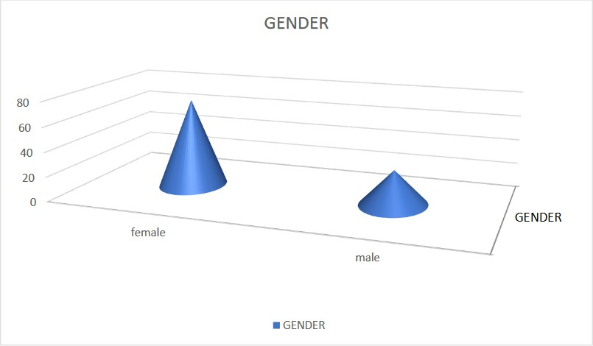

TABLE 3

OCCUPATION

S.NO PARTICULARS | PARTICULARS | NO OF RESPONDENTS | % OF RESPONDENT
1. | Self employed | 25 | 25
2. | Professional | 20 | 20
3. | Government employee | 25 | 25
4. | Private job | 20 | 20
5. | Students | 10 | 10
 | Total | 100 | 100

Interpretation:
From the above table it is inferred that 25 percentage of respondents are self employed, 20 percentage of respondents are professional, 25 percentage of respondents are government employee,20 percentage of respondents are private job, 10 percentage of respondents are students.

CHART 3

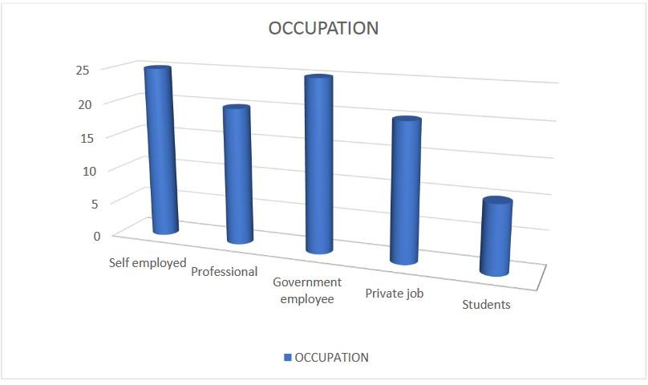

TABLE 4

MONTHLY INCOME

S.NO | PARTICULARS | NO OF RESPONDENTS | % OF RESPONDENTS
1. | Less than 10000 | 10 | 10
2. | 10000 to 20000 | 20 | 20
3. | 20000 to 30000 | 25 | 25
4. | 30000 to 40000 | 30 | 30
5. | More than 40000 | 15 | 15
 | Total | 100 | 100

Interpretation:
From the above table it is inferred that 10 percentage of respondents are less than 10000, 20 percentage of respondents are 10000 to 20000, 25 percentage of respondents are 20000 to 30000,30 percentage of respondents are 30000 to 40000, 15 percentage of respondents are more than 40000.

CHART 4

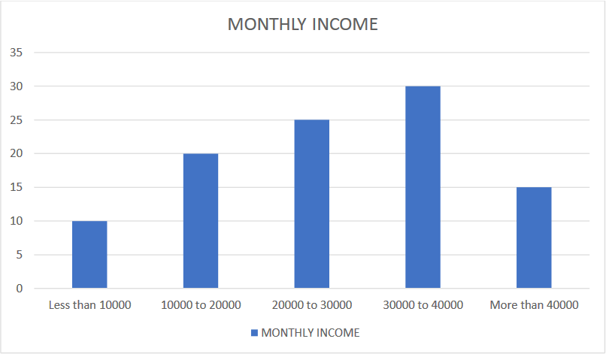

TABLE 5

WILL YOU WATCH ADVERTISEMENTS IN TV

S .NO | PARTICULARS | NO OF RESPONDENTS | %OF RESPONDENTS
1. | Yes | 80 | 80
2. | No | 20 | 20
 | Total | 100 | 100

Interpretation:
From the above table it is inferred that 80 percentage of respondents are said Yes, 20 percentage of respondents are said No.

CHART 5

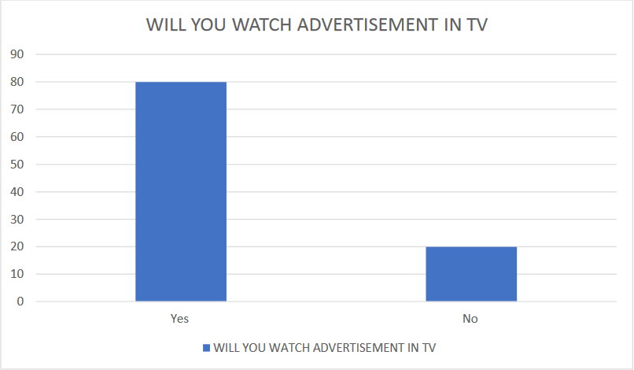

TABLE 6

HAVE YOU SEEN HIMALAYA ADVERTISEMENT

S .NO | PARTICULARS | NO OF RESPONDENTS | %OF RESPONDENTS
1. | Yes | 75 | 75
2. | No | 25 | 25
 | TOTAL | 100 | 100

Interpretation:
From the above table it is inferred that 75 percentage of respondents are said Yes, 25 percentage of respondents are said No.

CHART 6

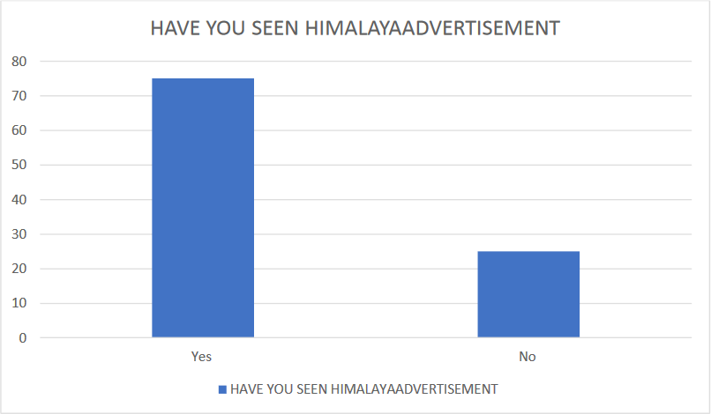

TABLE 7

WHAT WAS THE SOURCE OF INFORMATION ABOUT THE PRODUCT
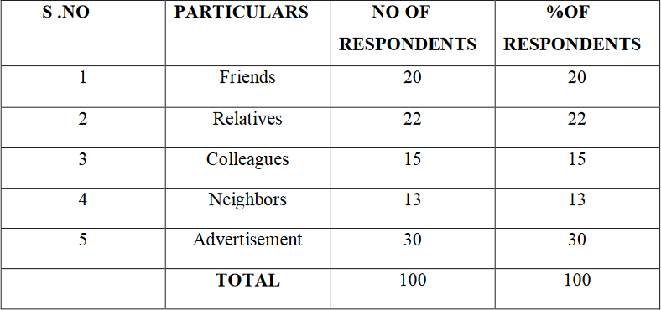

Interpretation:
From the above table it is inferred that 20 percentage of respondents are friends, 22 percentage of respondents are relatives, 15 percentage of respondents are colleagues,13 percentage of respondents are neighbors, 30 percentage of respondents are advertisement.

CHART 7

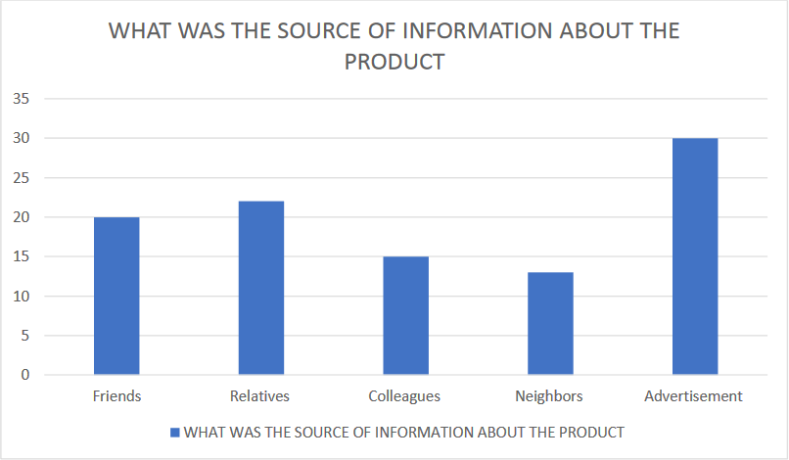

TABLE 8

YOU ARE TAKING THE DECISIONS REGARDING THE PURCHASE IN YOUR FAMILY

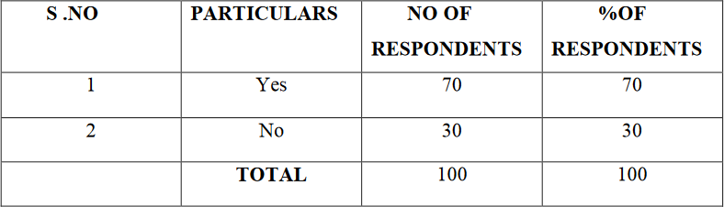

Interpretation:
From the above table it is inferred that 70 percentage of respondents are said Yes, 30 percentage of respondents are said No.

CHART 8

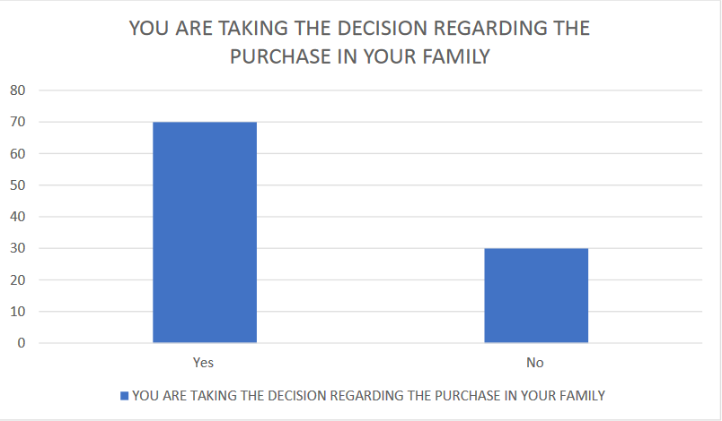

TABLE 9

WHAT ARE THE PRODUCT SEGMENT OF HIMALAYAYOU ARE USING

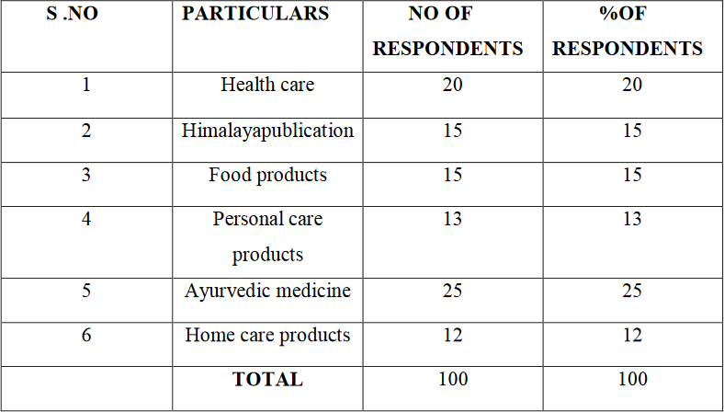

Interpretation:
From the above table it is inferred that 20 percentage of respondents are Health care, 15 percentage of respondents are Himalaya publication, 15 percentage of respondents are Food products,13 percentage of respondents are Personal care products, 25 percentage of respondents are Ayurvedic medicine, 12 percentage of respondents are Home care products.

CHART 9

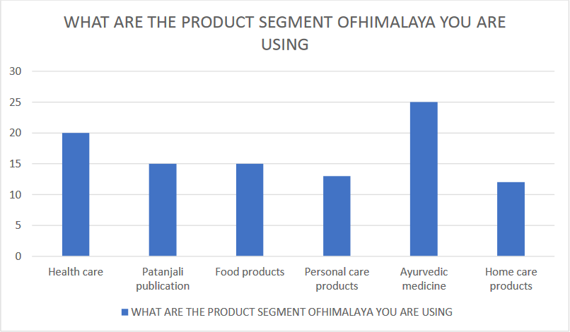

TABLE 10

YOU ARE GETTING ALMOST ALL VARIETY OF PRODUCTS
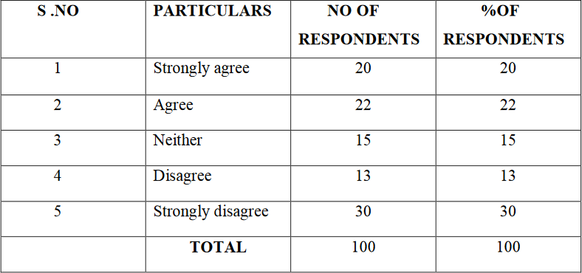

Interpretation:
From the above table it is inferred that 20 percentage of respondents are strongly agree, 22 percentage of respondents are agree, 15 percentage of respondents are neither,13 percentage of respondents are Disagree, 30 percentage of respondents are strongly disagree.

CHART 10

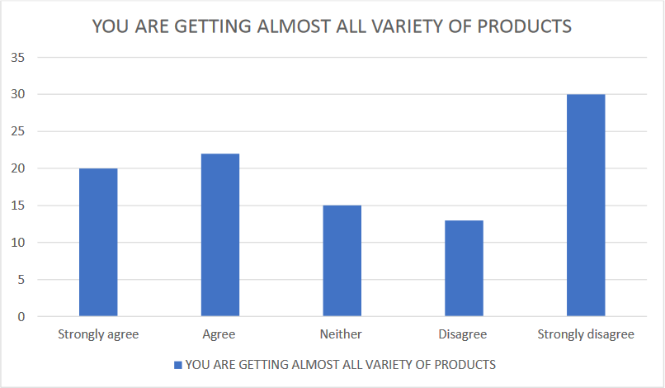

CHAPTER-V
FINDINGS, SUGGESTION AND CONCLUSION

FINDINGS
- Major 30 percentage of respondents are 20-25, 30 percentage of respondents are 25-30
- Major 72 percentage of respondents are female
- Occupation based 25 percentage of respondents are self employed, 20 percentage of respondents are professional, 25 percentage of respondents are government employee,20 percentage of respondents are private job, 10 percentage of respondents are students.
- Major 25 percentage of respondents are 20000 to 30000
- 80 percentage of respondents are said Yes, 20 percentage of respondents are said No from know about the advertisement
- Regarding view advertisement 75 percentage of respondents are said Yes, 25 percentage of respondents are said NO
- Source of information based 20 percentage of respondents are friends, 22 percentage of respondents are relatives, 15 percentage of respondents are colleagues,13 percentage of respondents are neighbors, 30 percentage of respondents are advertisement
- Product segmentation based 20 percentage of respondents are Health care, 15 percentage of respondents are Himalaya publication, 15 percentage of respondents are Food products,13 percentage of respondents are Personal care products, 25 percentage of respondents are Ayurvedic medicine, 12 percentage of respondents are Home care products
- Suggestion based major 30 percentage of respondents are strongly agree
- Availability based major 30 percentage of respondents are agree

SUGGESTIONS
  - Himalaya should organize campaign for general awareness of end consumers, because the consumers demand for the medicines based on the suggestions and on their own wish or knowledge.
  - Himalaya should organize free medical checkup camps over a fixed duration of time.This will help in the fulfillment of corporate social responsibility. This will also help in creating a brand image in the consumers mind.
  - Himalaya should also target market in remote areas. Because in remote areas people generally use medicines based on their own knowledge or on the Retailer suggestion
  - The company can lure the Retailer with some gifts or some special offer by achieving a fixed sales target. In villages or in the less developed area Retailer are generally treated as a doctor. They can suggest their customer for the Himalaya
  - The executives of the company should also target the doctor in the remote areas or villages, whether they are MBBS or not.
  - The executives should be always in touch with doctors who are not prescribing Himalaya or, not the core doctors for the company. The executives should try to motivate them by giving exiting gift to them or, having a facility of good commission on sales made through them The doctors should be provided with gifts which will fit and look good on their table.This will make recall to them about Himalaya when they make prescription. This will also motivate them towards the Himalaya.
  - Himalaya can organize camps in the school or colleges for the general awareness about the Ayurveda. This will make people aware about the benefits of Himalaya and motivate for the use of Ayurvedic medicines.
  - Himalaya should also enter in the surgical products. Because the demand of the surgical products is increasing day by day. This will create a business base and market opportunity for the Himalaya. The will surely get benefit of having a brand name.
  - Himalaya should also try to get opportunity in the general medicines, i.e. fever, pain,etc. People having interest in Ayurveda will get a good option for themselves and company will have a great customer base.
  - Himalaya should take suggestion from the doctors side for the new medicines in Doctors Meet Programme (DMP).
  - Himalaya can sponsor the programmes which are directly related to doctors, or which serves the doctors. This will motivate them and make them to feel good towards the Himalaya. Eg- Lions club, Rotary club, etc.

CONCLUSION
Himalaya Drug Company is the oldest Ayurvedic drug manufacturing company in the India. It deals in both Pharma and FMCG (cosmetics) both. In the available Pharma range Himalaya is the most reputed company. Himalaya mainly beliefs and engage in ethical promotion to doctors. It helps executive to motivate doctors for the prescription of Himalaya.It also helps executive to know the doctors requirement in turn of prescribing the Himalaya.During the meeting they also become aware about the competitors promotional strategy and the product available under their brand. Chemist who deals in Himalaya herbal are highly satisfied with their business of Himalaya. According to the chemist the customers who are consuming Himalaya are satisfied with the result. Although it is an Ayurvedic medicine its effect is slow but it is effective for long time. Most of the chemist rated it as a average selling medicine at their shop. Few medicines are recognized as a very high seller at the chemist shop, eg- Liv-52, Cystone, Rumalaya Forte, etc

BIBILIOGRAPHY

    - Dr,G.Venkatesh(2015) “Consumer Attitude Towards Amway”, Intercontinental journal of marketing Volume 3, Issue 11, November 2015 page 13
    - Dr. Nandhini (2014) “A Study on Customer Satisfaction Towards Amway Products in Coimbatore City”International Journal Of Marketing, Financial Services &Management Research
    - Dr. B .Banupriya (2014) “A Study on Customer Awareness And Perception Towards Lakhme in Andra Pradesh”, International Journal Of Marketing, Financial Services & Management Research Vol.3 (10), October (2014), pp. 143-151
    - Dr.S.Jamuna(2015) “A Study on Customer Satisfaction Towards Ponds Skin Care:,iosrjournals.org/iosr-jbm/4/31.pdf
    - Sowmya N(2015) “ A Study on the Usage Of Herbal Cosmetics By Selected Subjects”, Ijemr –june 2013-vol 3 issue 6 - online - issn2249–2585 -Mprint – issn 2249-8672 1 www.aeph.in
    - HimaniDahiya (2014) “Markeing a product – Face Wash”, International Journal for Research in Management and PharmacyVol. 3, Issue 4, May 2014

QUESTIONNARIE

- Name:
- What is your age group?
  - 15-20
  - 20-25
  - 25-30
  - 30 and above
- What is your gender?
  - Male
  - Female
- What is your occupation?
  - Self employed
  - Professional
  - Government employee
  - Private job
  - Student
- What is your monthly income?
  - Less than 10000
  - 10000 to 20000
  - 20000 to 30000
  - 30000 to 40000
  - More than 40000
- Will you watch advertisements in TV?
  - YES
  - NO
- Have you seen Himalaya advertisement?
  - YES
  - NO
- what was the source of information about the product?

  - Friends
  - relatives
  - colleagues
  - neighbors
  - Advertisement
- You are taking the decisions regarding the purchase in your family?
  - YES
  - NO
- What are the product segment of Himalaya you are using? (tick one)
  - Health care
  - Himalaya publication
  - Food products
  - Personal care products
  - Ayurvedic medicine
  - Home care products
- You are getting almost all variety of products
  - strongly agree
  - agree
  - Neither
  - Disagree
  - strongly disagree
- Its products quality is better than other companies
  - strongly disagree
  - Disagree
  - Neither
  - Agree
  - strongly agree

